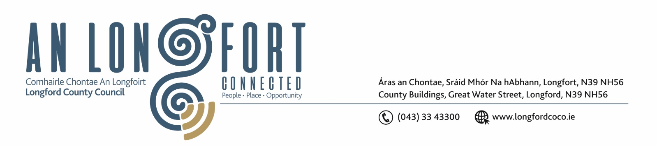

22nd September 2020.

To: Each Member of the Joint Policing Committee.

Re: Meeting of the Joint Policing Committee

Dear Member,

I wish to inform you that the next meeting of the Joint Policing Committee will take place
on Monday, 28th September 2020 at 3.00 p.m. to transact business, as set out on the Agenda hereunder.

Due to the ongoing advice from the HSE regarding the COVID-19 Pandemic, the meeting will be held via Microsoft Teams.

Please click on the link in this email to join the meeting.

Please do not hesitate to contact me if you have any queries.

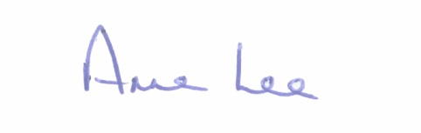
Yours sincerely,

___________________
Anne Lee,
Administrative Officer.

AGENDA

1. Confirmation of Minutes of Joint Policing Committee meeting held on the
6th July 2020 - enclosed.

2. Matters arising.

3. Declaration of Interest by Members.

4. Apologies received.

5. To note resignation of Ms. Emma Kiernan, representative of the PPN, from Longford Joint Policing Committee.

6. Garda Report.

7. Local Authority Report.

8. Presentation by Senior Officer for Longford Town CCTV on the following -
- Longford Town CCTV – Alternative Measures Report
Consideration for adoption of report and included recommendations on the alternative measures implemented for Longford Town CCTV System
- Longford Town CCTV – Report on Public Consultation for Existing and Additional Cameras
Consideration for adoption of report and included recommendations on the public consultation held in relation to existing and additional camera locations for Longford Town CCTV System.
- Consideration of Data Privacy Impact Assessment Reports for existing and additional camera locations for Longford Town CCTV System.
- Consideration of letter of approval by JPC for the new CCTV locations as per the above reports.

The above documents are available to view and download at the address below:
https://longfordcoco-my.sharepoint.com/:f:/g/personal/dlynch_longfordcoco_ie/Ei1p8sUj7AtAoN7jEZV5tSkBMMo5bE-TimEo81CMl9H-eg?e=roAxDd
9. Longford County Council’s Citizen Notifications System.

10. Joint Policing Committee – County Longford Annual Work Plan 2020/2021 – enclosed.

11. Bye-Laws prohibiting drinking in public places.

12. Update on Longford Joint Action Plan.

13. Notice of Motion submitted by Councillor Gerry Warnock.

“I am calling on Longford County Council and Longford Joint Policing Committee to write to the Minister for Justice and the Minister for Public Expenditure to make provisions where monies confiscated under the Proceeds of Crime legislation be redirected from central coffers to a local fund where local groups involved in addiction services, youth activities and community initiatives can avail of much needed revenue options to help them in their work to counter the negative impact of criminality on the local stage.”

14. Date of next meeting.

